# 

# **Assessment # 3– (15%)**

**Name :**

**ID No :**

**Section:**

1. **Consider the discrete time signals:**
$$u\left[n\right]= \left\{\begin{matrix}n 0≤n≤4 \\ 0 otherwise\end{matrix}\right\}$$

$$p\left[n\right]= \left\{\begin{matrix}3n 0≤n≤4 \\ 0 otherwise\end{matrix}\right\}$$

$$x\left[n\right]= \left\{\begin{matrix}2^{n} 0≤n≤4 \\ 0 otherwise\end{matrix}\right\}$$

2. Define the signal **u**, **p**, **x** and plot them respectively in the same **figure**.
3. Label the vertical and horizontal axes properly and give **any** title to the figure.
4. Evaluate the convolution of the **u** and **p** and plot it in another figure.
5. Evaluate the convolution of the **p** and **x** and plot it in another figure.
6. Evaluate the convolution of the **x** and **u** and plot it in another figure.
7. Comment with your own words on the length of each signal and each convolution.

**Code**

clc

clear all

close all

% discrete time

n=0:4;

% function

u=@(n) n;

p=@(n) 3*n;

x=@(n) 2.^n;

% plot all signals

stem(u(n))

hold on

stem(p(n))

hold on

stem(x(n))

hold on

grid

legend('u[n]','p[n]','x[n]')

xlabel('n')

ylabel('functions')

title('Discrete Time Signals')

% u and p conv

part_c=conv(u(n),p(n));

figure

stem(part_c)

xlabel('n')

ylabel('u[n]*p[n]')

title('u[n]*p[n]')

% p and x conv

part_d=conv(p(n),x(n));

figure

stem(part_d)

xlabel('n')

ylabel('p[n]*x[n]')

title('p[n]*x[n]')

% x and u conv

part_e=conv(x(n),u(n));

figure

stem(part_e)

xlabel('n')

ylabel('x[n]*u[n]')

title('x[n]*u[n]')

% part f

% the length of the conv function is the 2*n-1 in each case

**Output**

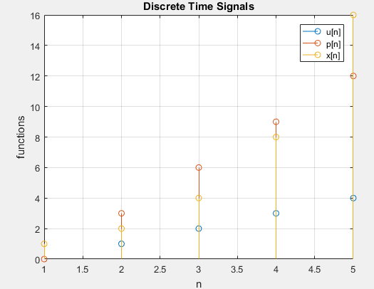

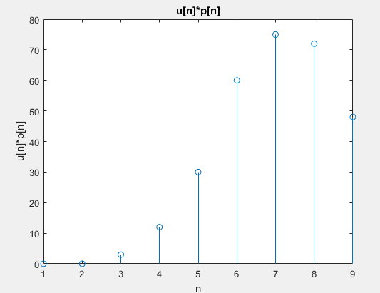

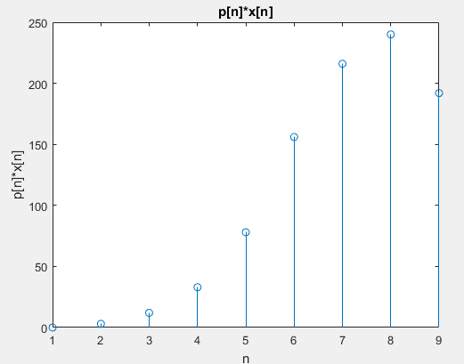

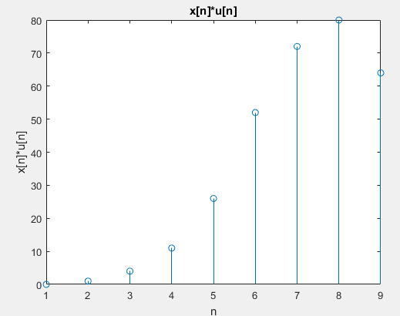

1. **Consider the continuous-time system at rest represented by the differential equation**

$$A\ddot{y}\left(t\right)- \dot{By}\left(t\right)-Cy\left(t\right)=\dot{Dx}\left(t\right)+Ex(t)$$

Where A= 1, B=3, C=3, D=2 and E=4.

Take t= 5 s and Ts=0.1. Write MATLAB code to find and plot

1. the impulse response of the system;
2. the step response of the system

Using the MATLAB functions **step** and **lsim**

**Code**

**Output**

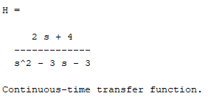

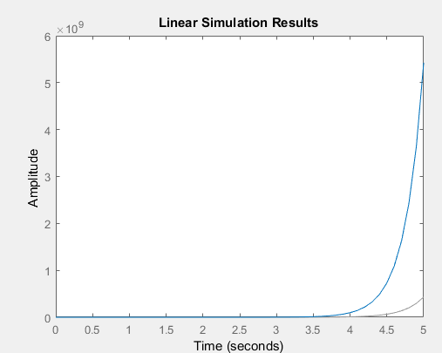

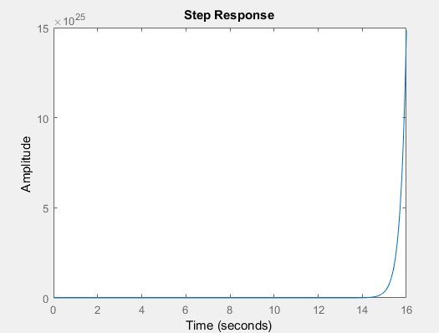

1. **Assume that you have the signals below.**
$f(x)=\cos\left(5πx-π\right)$

$h(x)=7sin\left(45πx-π/6\right)$

2. Add these signals, and plot the result within $0≤x≤\frac{3}{4}π$ (increment is 0.02)
3. Multiply these signals and plot its result in a separate figure. (use the same range)
4. For each figure, add a title, x-axis name and y-axis name.
5. Are these signals periodic? Explain.

**Code**

clc

clear all

close all

% define x

x=0:0.02:3/4*pi;

% generate f and h

f=cos((5*pi*x)-pi);

h=7*sin((45*pi*x )- (pi/6));

% plot f and h

figure

subplot 121

plot(f)

xlabel('t')

ylabel('Mag')

title('f')

subplot 122

plot(h)

xlabel('t')

ylabel('Mag')

title('h')

% addition of f and h

part_a=f+h;

figure

plot (part_a)

title('f(x)+h(x)')

xlabel('x')

ylabel('Mag')

% Multiplication of f and h

part_b=f.*h;

figure

plot (part_b)

% part c

% plot and label

title('f(x)*h(x)')

xlabel('x')

ylabel('Mag')

% part d

% yes, signal are periodic. signals repeat it self after some interval

**Output**

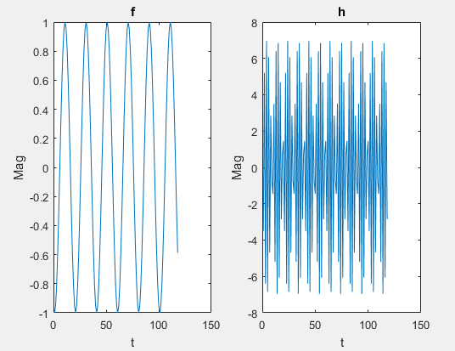

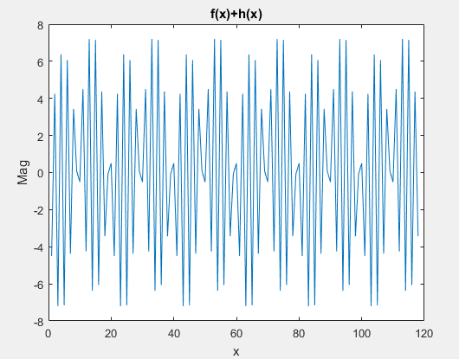

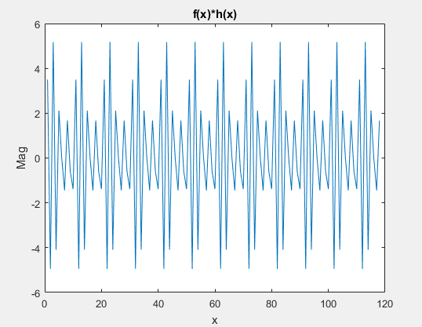

1. **Pick one of the options:**
   1. **Write with your own words a short summary that explains ALL of the Labs, Lab 5, Lab 6 AND Lab 7. (Minimum 6 sentences)**
   2. **Write with your own words a detailed summary that explains ONE of the Labs, Lab 5, Lab 6 OR Lab 7. (Minimum 6 sentences)**

**Note:** This Assessment is based on the course Material from Lab 5, Lab 6 and Lab 7. MATLAB software is **NOT** required to successfully complete the Assessment. If you have the MATLAB software, you can use it to verify your answers. If you do not have the MATLAB software, you can complete your answers directly in the Word file. **HANDWRITTEN** submission will **NOT** be accepted. You need to submit a word/PDF file in the provided **Turnitin link** with all the answers to the above questions. Make sure to include comments with your code. If you have any queries do not hesitate to contact your instructor via email or Moodle.